Q1) Write a class with FirstName, LastName & age field. Print FirstName, LastName & age using static block, static method & static variable respectively.

Ans1)

public class Student {

static String *firstName*;

static String *lastName*;

static int *age*;

static{

*firstName* = "Amritpal";

*lastName* = "Singh";

*age* = 23;

}

public static void display(){

System.*out*.println("FirstName: "+Student.*firstName*+"\nLastName: "+Student.*lastName*+"\nAge: "+Student.*age*);

}

public static void main(String[] args) {

*display*();

}

}

Output: -

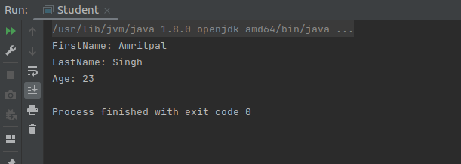

Q2) Write a program to read user input until the user writes XDONE and then show the entered text by the user on the command line.

Ans2)

import java.util.Scanner;

public class Main {

public static void main(String[] args) {

String s1="",s2="";

do {

Scanner sc = new Scanner(System.*in*);

s1=sc.nextLine();

s2 += s1+"\n";

}while(!s1.equalsIgnoreCase("XDONE"));

System.*out*.println(s2);

}

}

Output: -

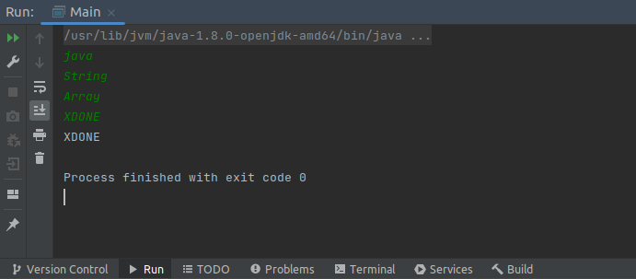

Q3) Write a java program to show following menu to the user:

*******Menu*******

1. Calculate Area of Circle

2. Calculate Circumference of a Circle

3. Exit.

Choose an option (1-3):

Take radius as user input.

Hint: Use Switch statement to act on the menu. Also area and circumference methods should be static

Ans3)

import java.util.Scanner;

public class Main {

static int *radius*;

static double Area(){

double area = 3.14 * *radius* * *radius*;

return area;

}

static double circumference(){

double circumference = 2 * 3.14 * *radius*;

return circumference;

}

public static void main(String[] args) {

Scanner sc = new Scanner(System.*in*);

int choice;

do {

System.*out*.println("**********Menu***********\n1. Area\n2. Circumference\n"

+ "3. Exit\n*************************\nEnter choice\n");

choice = sc.nextInt();

switch (choice) {

case 1:

System.*out*.println("Enter radius");

Main.*radius* = sc.nextInt();

double area = Main.*Area*();

System.*out*.println("Area of Circle : "+area);

break;

case 2:

System.*out*.println("Enter radius");

Main.*radius* = sc.nextInt();

double circumference = Main.*circumference*();

System.*out*.println("Circumference of Circle : "+circumference);

break;

case 3:

System.*out*.println("Exited");

}

} while (choice != 3);

}

}

Output: -

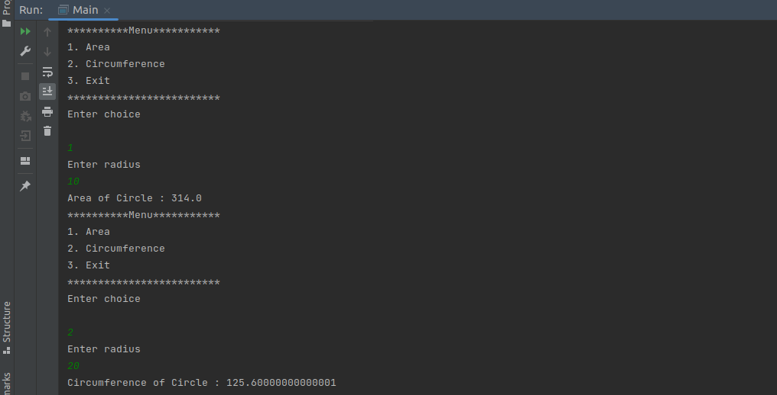

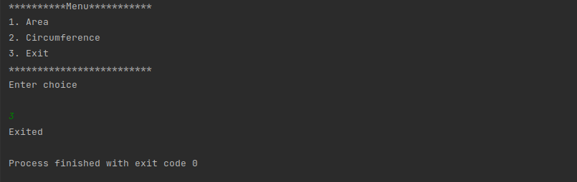

Q4) Create a two dimensional array of integers and display:

* sum of all elements of each column
* sum of all elements of each row

Ans4)

public class Main {

public static void main(String[] args) {

int[][] array = {

{1,2,3,4},

{4,5,6,7},

{6,7,8,9},

{9,10,11,12}

};

int[] new_array_col = new int[5];

int[] new_array_row = new int[5];

for(int i=0;i<array.length;i++){

for(int j=0;j<array[i].length;j++){

new_array_col[i] += array[j][i];

new_array_row[i] += array[i][j];

}

}

System.*out*.println("sum of all elements of each column");

for(int i=0;i<array.length;i++){

System.*out*.println("Column "+i+": "+new_array_col[i]);

}

System.*out*.println("sum of all elements of each row");

for(int i=0;i<array.length;i++){

System.*out*.println("Row "+i+": "+new_array_row[i]);

}

}

}

Output: -

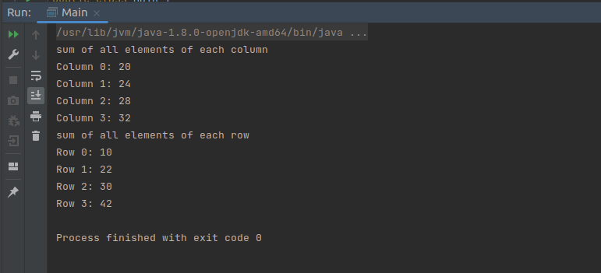

Q5) Create a class named Employee with fields firstname,lastname,age and designation.

The class should:

* have all types of constructors to initialize the object
* class should also have setter methods to update a particular field
* Override its toString method to display a meaningful message using all these fields.

Ans5)

Employee class -

public class Employee {

String first_name;

String last_name;

int age;

String designation;

Employee(){

first_name = null;

last_name = null;

age=0;

}

public void setFirst_name(String first_name) {

this.first_name = first_name;

}

@Override

public String toString() {

return

"first_name=" + first_name +

", last_name=" + last_name +

", age=" + age +

", designation=" + designation;

}

public void setLast_name(String last_name) {

this.last_name = last_name;

}

public void setAge(int age) {

this.age = age;

}

public void setDesignation(String designation) {

this.designation = designation;

}

Employee(String first_name, String last_name, int age, String designation){

this.first_name = first_name;

this.last_name = last_name;

this.age = age;

this.designation = designation;

}

Employee(Employee e){

first_name = e.first_name;

last_name = e.last_name;

age = e.age;

designation = e.designation;

}

}

Main class -

public class Main {

public static void main(String[] args) {

System.*out*.println("Creating object using default constructor");

Employee e1 = new Employee();

System.*out*.println("Employee1 Details: \n"+e1);

e1.setFirst_name("Amritpal");

e1.setLast_name("Singh");

e1.setAge(23);

e1.setDesignation("Software Engineer");

System.*out*.println("\nAfter calling setter method\nEmployee1 Details:");

System.*out*.println(e1);

System.*out*.println("\nCreating object using parameterized constructor\nEmployee2 Details: ");

Employee e2 = new Employee("Rakesh","Kumar",26,"Software Engineer");

System.*out*.println(e2);

System.*out*.println("\nCreating object using copy constructor\nEmployee3 Details: ");

Employee e3 = new Employee(e1);

System.*out*.println(e3);

}

}

Output: -

